Find Education & Psychology Scholarly Articles

To find scholarly Scholarly Articles using ERIC & our Psychology Collection
- Go to the library website at http://skylinecollege.edu/library/ click Databases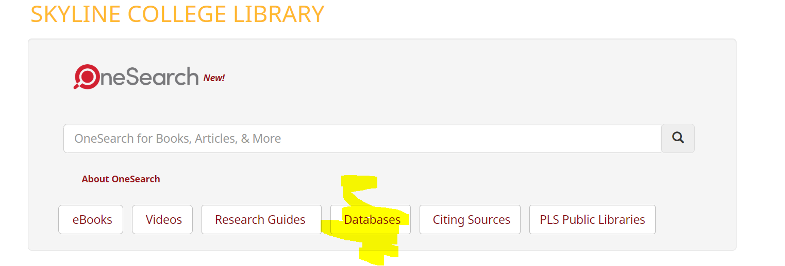
- Then click Select Database by Title
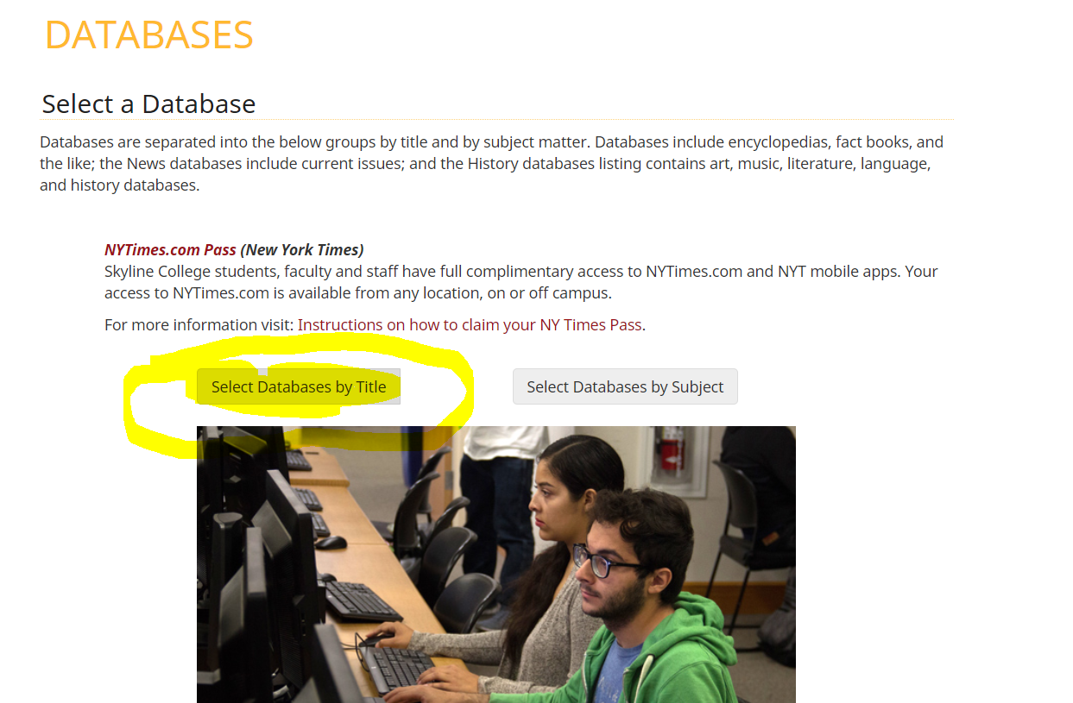
- Then click or scroll down to the databases that begin with the letter E. 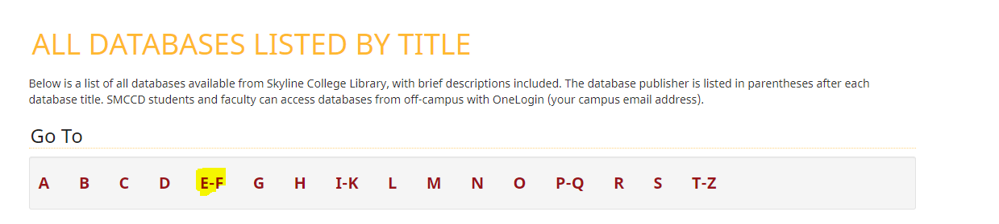
- Then click ERIC. 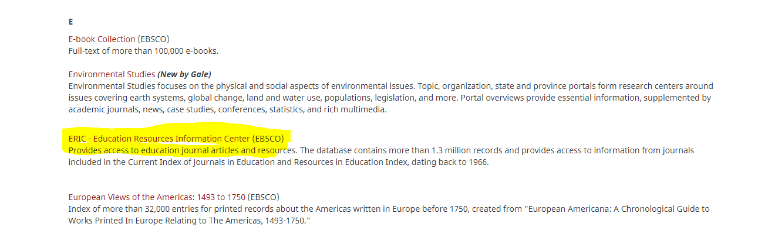
- If you’re looking for education articles, being your search by entering your search terms.
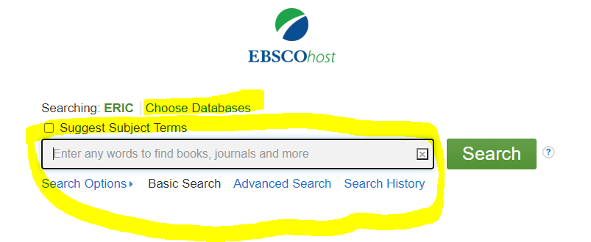
If you’d like to add the psychology database(s) click choose databases above the search box. A window will pop up. Select Psychology & Behavioral Sciences Collection & APA PsychArticles then click OK.
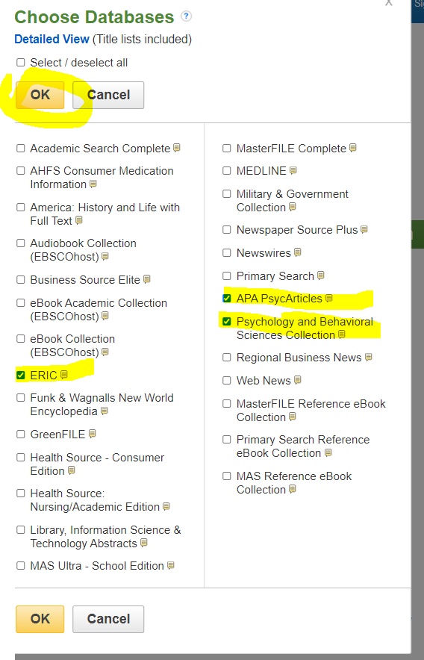
- Enter your Search terms in the search box
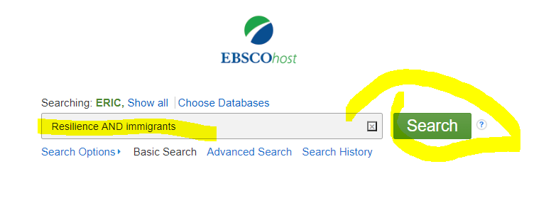

- Search Tips
  - When AND is between two words, your search results will be limited to sources that contain both words. For example: Twitter AND identity
  - OR expands your search since either word can appear in your search results. For example teenage girls OR young women
  - Use quotations (know as "phrase searching") to limit the search results. The words in quotation marks will be searched as an exact phrase (Links to an external site.) For example: "social media"
  - Use an asterisk* for alternate word endings, For example: teach* will pull results containing teaching, teach, teacher, etc.

- To limit your results to scholarly on the refine search results menu limit to academic journals and/or peer review. You can also limit the date in the same area. 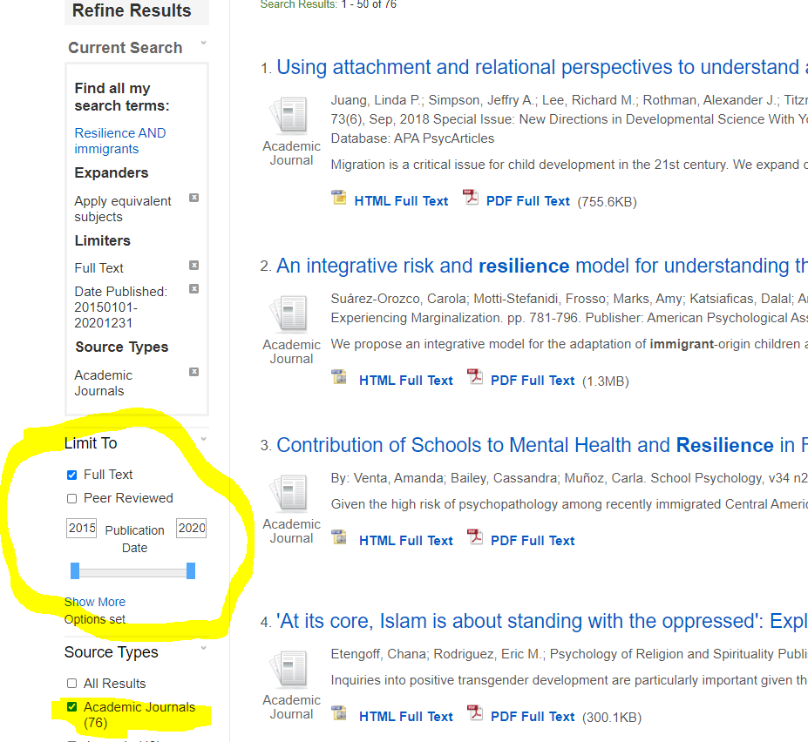
- Click the title of an article to find the entire article fulltext. Email it to yourself, save it to your google drive and or copy the citation information.
